PROJECT NAME: STUDENT REGISTRATION SYSTEM
BACHELOR OF SCIENCE IN TELECOMMUNICATION AND INFORMATION ENGINEERING
DATE: 22ND JANUARY 2026
UML DIAGRAM REPORT
NAME | REG NO | ROLES
IAN BWALEI | E020-01-1527/2023 | REQIUREMENTS ANALYST
TITUS KAIBOS | E020-01-0927/2023 | REQUIREMENT ANALYST
GILBERT KEMBOI | E020-01-0926/2023 | SYSTEM DESIGN
BRIAN SOME | E020-01-0929/2023 | SYSTEM DESIGN
ARNOLD MURITHI | E020-01-0937/2023 | JIRA PROJECT MANAGER
ALVIN NG’ANG’A | E020-01-2078/2023 | JIRA PROJECT MANAGER
GLORIA CHEPCHUMBA | E020-01-0912/2023 | UML DIAGRAMS
ABIGAEL CHEROTICH | E020-01-0913/2023 | UML DIAGRAMS
IVY CHEPKURUI | E020-01-0905/2023 | DOCUMENTATION LEAD
PAULINE WAMBETE | E020-01-0881/2023 | DOCUMENTATION LEAD

INTRODUCTION
This chapter describes the design of the Student Registration System using UML diagrams. The diagrams were developed to represent the system from different perspectives, including its structure, workflow, functionality, and interactions between components.
The following diagrams are presented:
Class Diagram
Activity Diagram
Use Case Diagram
Sequence Diagram
Each diagram plays a specific role in explaining how the system operates.
CLASS DIAGRAM
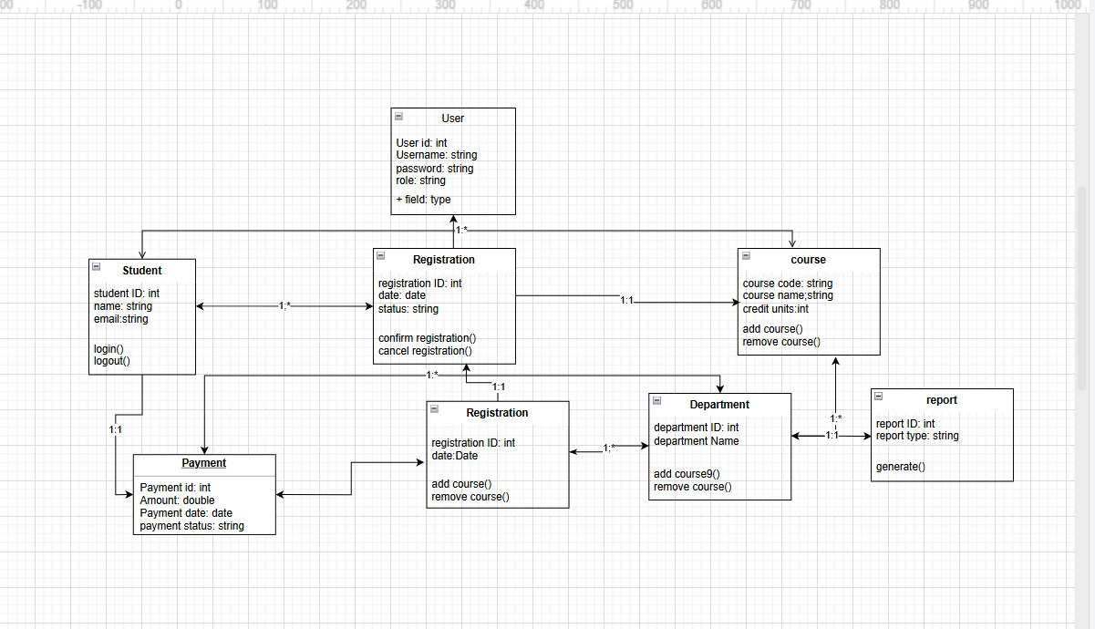
The class diagram illustrates the static structure of the system. It shows the main classes, their attributes, methods, and the relationships between them.

The central class in the system is the User class, which contains general attributes such as user ID, username, password, and role. This class provides a common structure for system users.
The Student class represents students who interact with the system. It contains student details such as student ID, name, and email. Students are able to log in, register for courses, and make payments.
The Registration class stores information about course enrolment. It contains details such as registration ID, date, and status. A student can have multiple registrations, and each registration is associated with a specific course.
The Course class holds course-related information, including course code, course name, and credit units. Courses are managed by departments.
The Department class stores department information and is responsible for managing courses offered within that department.
The Payment class records financial transactions made by students. It includes payment ID, amount, payment date, and payment status. Payments are linked to student registrations.
The Report class allows the system to generate reports for administrative purposes.
The relationships between these classes ensure proper data organization and maintain logical connections between students, courses, registrations, and payments. This structure supports object-oriented design principles and provides a clear blueprint for database implementation.

ACTIVITY DIAGRAM
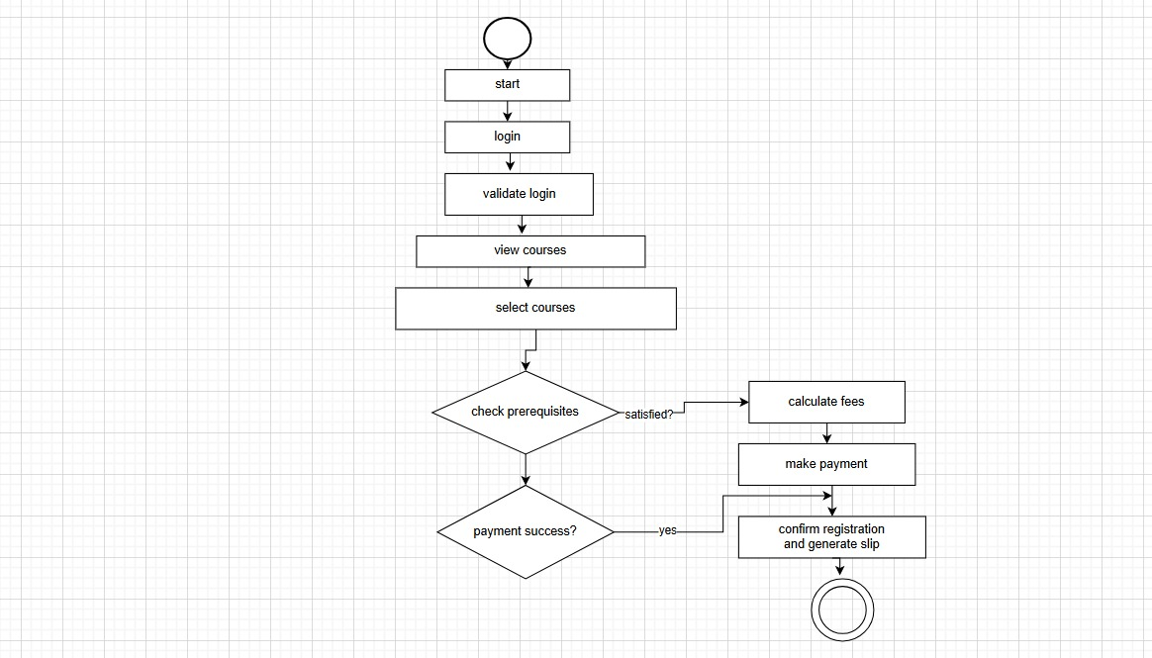

The activity diagram represents the step-by-step workflow of the student registration process.
The process begins when the student logs into the system. The system validates the login credentials before allowing access. Once authenticated, the student can view available courses and select the desired courses.
After course selection, the system checks whether the prerequisites are satisfied. If the prerequisites are not met, the process stops. If they are satisfied, the system proceeds to calculate the required fees.
The student then makes payment. The system verifies whether the payment was successful. If payment fails, the registration is not completed. If payment is successful, the system confirms the registration and generates a confirmation slip.
This diagram clearly shows the decision points in the process, including prerequisite validation and payment verification. It ensures that all required conditions are met before registration is finalized.
USE CASE DIAGRAM
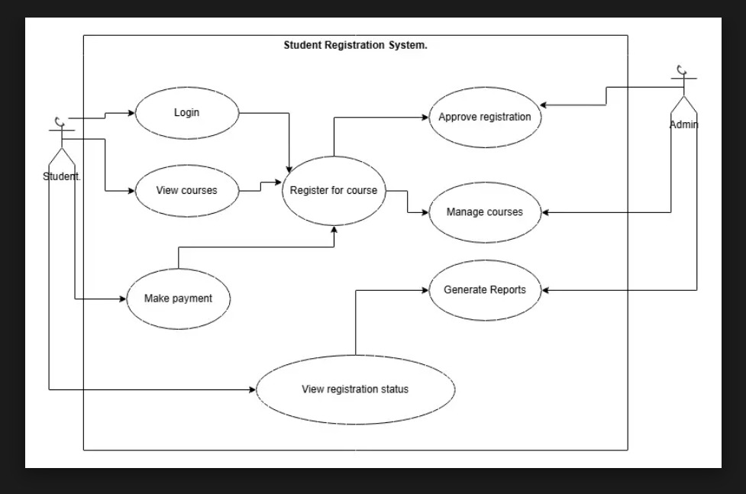

The use case diagram presents the functional requirements of the system and shows how different users interact with it.
There are two main actors in the system:
Student – who can:
Log in
View available courses
Register for courses
Make payments
View registration status
Admin – who can:
Approve registrations
Manage courses
Generate reports

The diagram defines the system boundary and highlights the services provided by the system to each user. It ensures that all required functionalities are clearly identified and assigned to the appropriate actors.

SEQUENCE DIAGRAM
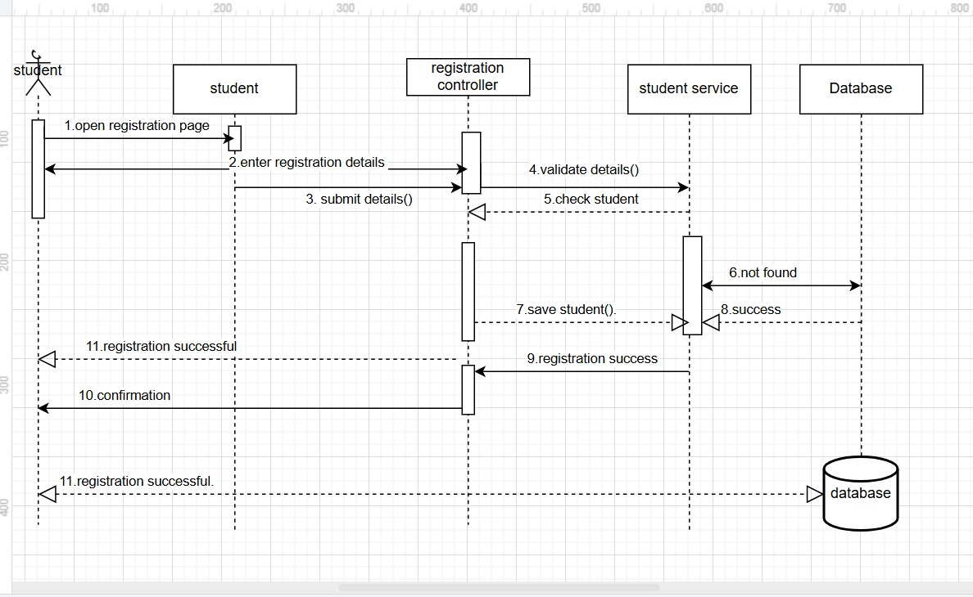

The sequence diagram shows how different components of the system interact during the registration process.
The process starts when the student opens the registration page and enters the required details. These details are submitted to the registration controller.
The controller validates the information and communicates with the student service to verify the student’s records. The student service interacts with the database to retrieve or store necessary data.

If the student record does not exist, a new record is created in the database. Once verification is successful, the system confirms the registration and sends a confirmation message back to the student.
This diagram helps illustrate how data flows between the user interface, system controller, services, and the database during execution.

